Systems Development Group Project Portfolio
Bristol-Pink Bakery Sales Prediction Dashboard
Module: UFCF7S-30-2 | Group Report and Individual Reflective Essay

Group Members:
UDDIN, NADER 24061972
CHENG, JILONG 25028281
XIE, JIAQI 25028285
YU, YUNZE 25028284
YANG, HAODONG 25061288

Group Report
This report explains the design and development of Bristol-Pink Bakery Sales Prediction Dashboard. It is a small decision - support tool for a caf and bakery business. The system helps managers get to know past sales patterns, try different forecasting methods, and make better production decisions.

1. Aims and Objectives

1.1 Project context and overall aim
Independent cafs and bakeries are often faced with products that do not last long. The daily demand may also vary significantly. This makes production planning a challenge due to this fact. In case the business overstocks, waste will be more and expenses will rise. But in case it prepares too little, it might lose sales and disappoint customers. Due to this, Bristol-Pink was an appropriate case of a system which integrates both sales analysis and short-term forecasting.
The project was primarily aimed at creating a functional dashboard. The dashboard converts historical transaction data into valuable information to the managers. It was not the goal of the project to develop a large or complex business system. Rather, it was concerned with an easy and convenient tool that could be executed on a standard Windows computer. The last dashboard allows users to upload CSV sales files, view previous trends in sales, compare forecasting models, and generate a 28-day forecast of selected bakery and coffee products.

1.2 SMART objectives
The project objectives were established in SMART form by the team. This helped to monitor development and determine whether the project goals had been achieved.
Specific - The project was intended to create a multi-page Streamlit dashboard. The dashboard has the data upload, data cleaning, historical sales analysis, model comparison, and 28-day forecast of bakery and coffee products.
Measurable - The project compared three forecasting models: Linear Regression, Random Forest and a 7-Day Moving Average. The performance was measured by the team using MAE, RMSE and MAPE. This enabled the evaluation of model results with evidence.
Achievable -The system was ready to be used locally by non-technical users. It has the ability to be deployed in an automated batch script. This implies that software libraries do not have to be installed manually by the user.
Relevant -The project was about the features that aid in daily stock decisions. These functions are displaying “best-selling items, latest sales trends and predicted results”. All these can be used to assist in purchasing and preparing.
Time-bound - The team intended to finish the planning, development, testing and documentation stages before April 2026 when they would submit the module.

2. Literature Review and Methods

2.1 Demand forecasting in a small retail setting
Demand forecasting is significant in small retail businesses since it relates past sales informationrelates past sales information to the daily business decisions. Managers base their buying, preparation, staff arrangement and waste reduction on forecasts. More accurate predictions usually result in more informed choices in hospitality and retail. According to Fildes et al. (2008), forecast quality has a potential of enhancing decision-making. Chase (2013) also demonstrates that lack of planning results in additional cost, particularly where the business deals with perishable products.
This is a more severe problem in a small bakery. The shelf life of bakery products is normally short. Due to this, managers are not able to store unsold items long. Therefore, short-term forecasting would be better than long-term forecasting in such environment. A bakery will usually require assistance over the next couple of days or weeks, rather than planning far into the future.
As it is demonstrated in the literature, forecasting is not a technical activity. A forecast can appear to be correct theoretically but must still be applicable to the actual business environment. According to Petropoulos, Makridakis and Assimakopoulos (2014), the worth of a forecast relies on the way individuals apply it in practice. That concept was relevant in this project. The system was not designed with the purpose of generating numbers only. It also sought to provide managers with results that they could read and apply within a short period of time in their daily work.

2.2 Forecasting methods used in the project
The project took into consideration both simple methods and machine- learning methods. This choice made the comparison more meaningful and practical for a small business case.
Conventional techniques like moving averages can still be applied. These techniques are simple to comprehend and simple to describe. According to Hyndman and Athanasopoulos (2018), even the simple time-series methods may prove effective in case sales trends remain relatively stable. Such approaches also give a rough point of reference. Due to that, they assist in demonstrating whether a more sophisticated model is actually enhancing the outcome. This type of comparison is significant in a student project since it avoids unnecessary complexity.
The usefulness of machine-learning methods increases with the irregularity of the sales data. There are some non-linear patterns in sales. Some patterns are influenced by various factors simultaneously. A simple average can fail to detect significant changes in these cases. According to Carbonneau, Laframboise and Vahidov (2008), machine learning is a promising direction in forecasting demand. However, Makridakis, Spiliotis and Assimakopoulos (2018) also note that there is no universal model that fits all situations. Because of this, this project did not suppose that one method would be the winner every time.
Random forests were included in the project for practical reasons. Random forests can handle nonlinear relationships. It can also be compatible with engineering functions. At the same time, it is easier to control than more complex neural network models. Nevertheless, the team did not regard complexity itself as a benefit. M4 competitive research shows that more complex methods may not produce excellent business value (Makridakis et al., 2020). Therefore, the establishment of a dashboard is to facilitate the comparison of models, rather than automatically trusting an advanced model.

2.3 Dashboard design and decision-making support
Predictions are only useful when users can understand and take action. Managers not only need to predict the results. Managers also need a transparent way to interpret the results and link them to actual business options. But alsoThat's why the design of the dashboard is so important.

According to business intelligence research, the most effective use of dashboards is to simplify the reading of information. Chen, Chiang and Storey (2012) described the BI system as a system that links raw data with management operations. Another point put forward by Few (2013) is that a good dashboard must help users quickly track important information. It should not overwhelm them with too many materials at once.These thoughts informed the creation of this project. The system did not put all functions in a single long page. Rather, the project divided the work into various sections. These sections were historical analysis, forecast generation, model evaluation and raw-data inspection. This format simplified the dashboard. It also rendered every task more specific. This direction was facilitated by feedback during development. The design is also similar to that presented by Knaflic (2015) who believes that visual communication must direct the attention of the user in an unambiguous manner.

2.4 Project gap and justification
Much of the forecasting literature is devoted to big data, large companies and sophisticated analytics systems. But small and medium-sized businesses are not always in such a position. They do not necessarily have large technical teams or expensive software. For them, many available tools are too complicated, too expensive, or too heavy to use on a daily basis.
An enterprise system is not typically required by a small caf or bakery. The manager frequently requires something far easier. The company requires a program that can clear up messy sales records, display which products are selling well and give a fair short-term forecast. Such support is more practical in the day-to-day activities than a complicated system with numerous features that are hardly used.
This gap has been considered in the design of this project. In practice, it integrates a Python-based low-cost system and a more user-friendly dashboard. The key advantage of this project is not that it puts forward a new theory. The value is that it shows how typical data science tools can be converted into effective decision-making support tools in a small business environment.
3. Project Management
3.1 Team structure and roles
The project is based on an agile working method. The team divided the work into several short stages. This makes it easier to change the plan, improve the interface and improve the prediction function during the development process. Each member of the team is responsible for tasks that match their advantages. At the same time, the team still needs to work closely together. The dashboard combines business analysis, interface design, data processing and testing. Therefore, each part must be compatible with other parts
Yu Yunze was the Business Analyst and Market viewer. He explained the business background of the project. He also prepared the literature review, transformed the business problem into SMART objectives and system requirements, and participated in the final evaluation.
Xie Jiaqi was the Front-end Developer. She created the Streamlit interface and assisted in structuring the technical functions into a multi-page user workflow.
Nader was the Back-end Developer and Data Scientist. He developed the key Python functions of the system. His work consisted of data cleaning, feature engineering, predicting functions and model evaluation metrics.
Cheng Jilong was a Systems Architect and Technical Writer. He contributed to the general structure of the system, created UML documentation, and assisted in maintaining alignment of the requirements, design, and implementation
Yang Haodong was the QA Lead and Evaluation Manager. He scheduled the testing tasks, verified that various modules could work in harmony with each other, and assisted in evaluating the advantages and constraints of the final system

3.2 Coordination, planning, and risk management
The version control system that was used by the team is Git. The development work was also coordinated through weekly meetings of the team. This was required since front-end and back-end were created simultaneously. In case there was lack of communication in the team, integration issues might manifest themselves very easily.

The early prototypes demonstrated that the key danger was not the failure of coding per se. The larger threat was bad integration among components. To illustrate, a segment of the dashboard might cease to function in case data structures were altered, filenames renamed or even in case of changing inputs of functions without notification. This might occur despite the fact that the code of each member worked well individually.
Due to this, the team employed a basic risk management strategy. The team was able to identify significant risks at an early stage. Then during progress meetings, the team reviewed these risks. The team also associated each risk with a practical response. Table 1 shows the main risks that carried on into the implementation phase.
Risk | Description | Probability | Impact | Mitigation
R01 | Conflicts may appear when the interface module and the forecasting module are combined. | Medium | High | The team should use Git branches, test merges often, and keep function inputs consistent.
R02 | Some CSV files may have missing values, unclear column names, or inconsistent labels. | High | High | The system must employ defensive parsing and cleaning rules. The system is also expected to inform the users when it skips invalid files.
R03 | The forecasting model may overfit or show unstable results when the training period is short. | Medium | Medium | The team is advised to compare models on a validation split and present MAE and RMSE explicitly rather than concealing poor model performance.
R04 | The schedule can be behind due to the lack of equal sharing of work or overreliance on one individual. | Low | High | The team should review progress every week, share basic knowledge across roles, and reassign tasks when needed.

3.3 Project schedule (Gantt chart)
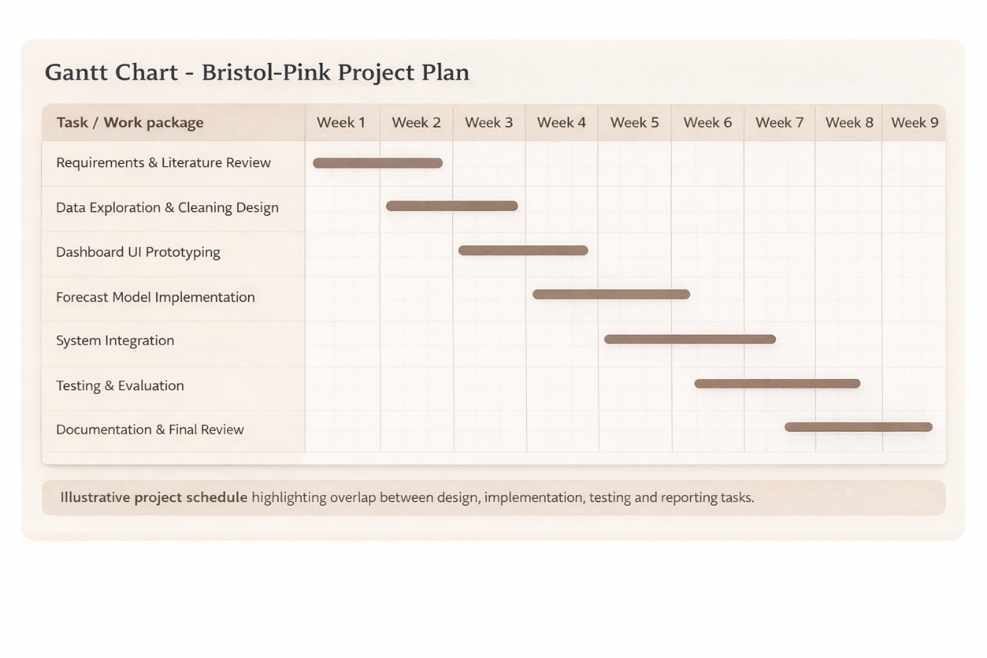Figure 1 shows the project schedule that was planned. The timeline included the major phases of the project. They involved requirements analysis, system implementation, integration, testing and final documentation.

4. Requirements
4.1 Requirement elicitation
The team recognized the system requirements in three key areas. The first one was the Bristol-Pink case study. This provided the project with its real business background. The second area was the literature review. This assisted the team to know what functions and design decisions were significant in other studies. The third aspect was the technical constraint of a student project. This maintained the system at a realistic level.
The mentor was the one who took the major role in verifying and ensuring that the requirements are met. This encouragement kept the team on track with real objectives. The team also did not attempt to incorporate features just because they appeared advanced or appealing. Rather, the team chose the requirements which can be constructed, tested and demonstrated easily.
The last requirements were also very much associated with the concepts that were identified in the literature review. Indicatively, the literature demonstrated that forecast outcomes must be comprehensible and therefore the system had accuracy reporting. The literature further indicated that dashboards should be user-friendly hence the system was structured into different workspaces. Similarly, the issue of unclean business data resulted in enhanced demands on data cleaning and preprocessing.
4.2 Functional requirements
ID | Requirement
FR1 | The system must allow users to upload one or more CSV sales files for analysis.
FR2 | The system must clean inconsistent product labels and merge duplicate records into a single daily time series.
FR3 | The system must visualise historical sales trends and highlight top-performing products.
FR4 | The system must generate 28-day forecasts using Linear Regression, Random Forest and a 7-Day Moving Average.
FR5 | The user must be able to adjust the model training window between 4 and 8 weeks.
FR6 | The system must export cleaned data and forecast outputs as CSV files.

4.3 Non-functional requirements
Non-functional requirements explain the way in which the system is supposed to operate, and not just what the system is expected to do. These requirements were usability, performance, reliability and maintainability in this project. The points were significant since the dashboard was meant to be used in practice within a small business environment.

NFR1 -The interface must divide major tasks in a clear manner. Users ought to be able to move between sales analysis, forecasting, and data inspection without confusion. This design can lower mental effort and make the dashboard more user-friendly.
NFR2 -The application must be installed on a normal Windows computer. The system must be started by the users using an automated batch script. This has the potential of making the system more accessible to non-technical users.
NFR3 -Common actions must be completed within a reasonable time. Such activities involve filtering of data, loading charts and forecasts generation. The system is to react fast enough to use it in normal daily life.
NFR4 -The system must be able to handle bad input data in a stable manner. It must not crash when faced with missing values, empty rows and unsupported file formats. It is also expected to provide clear warnings upon the emergence of problems.
NFR5 - Forecast results must contain MAE, RMSE and MAPE. These can be used to enable the users to have a better understanding of model performance and compare models in a more transparent manner.
NFR6 - The code should be modular and easy to read. This is important because future teams may need to maintain or extend the application. A clear code structure can make later development easier.

5. System Design and Testing

5.1 System design
The dashboard has a layered system design. This design separates the system into various parts and each part is assigned its own job. The presentation layer is constructed using Streamlit. This layer gives the user interface as well as the interactive controls. Pandas are used in the data processing layer. This layer parses, cleans and aggregates the data. The prediction models and the evaluation logic are present in the forecasting layer.
The reason behind this structure is that it maintains the responsibilities of the system distinct. The forecasting logic will not have to be rewritten in case the team alters the interface. Similarly, the data processing functions can be tested without relying on the page layout. This design makes development more systematic and facilitates subsequent changes.
This modular idea is also adhered to by the codebase. The team had distinct functions of repetitive work. Such activities were product name cleaning, time-series preparation, Random Forest feature engineering and metric calculation. This method minimized the duplication of code on the dashboard pages. It simplified testing as well as enhanced organisation of codes.
This system design discussion is supported by figures 2 and 3. They demonstrate the primary user interaction in the dashboard and the sequence of steps taken when the system produces a forecast.
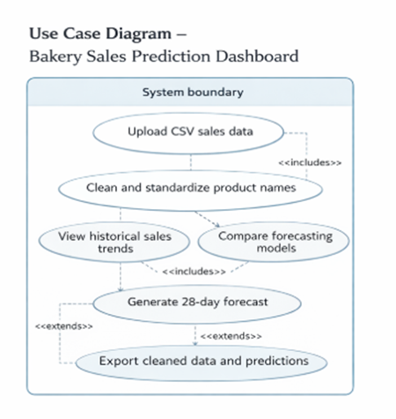
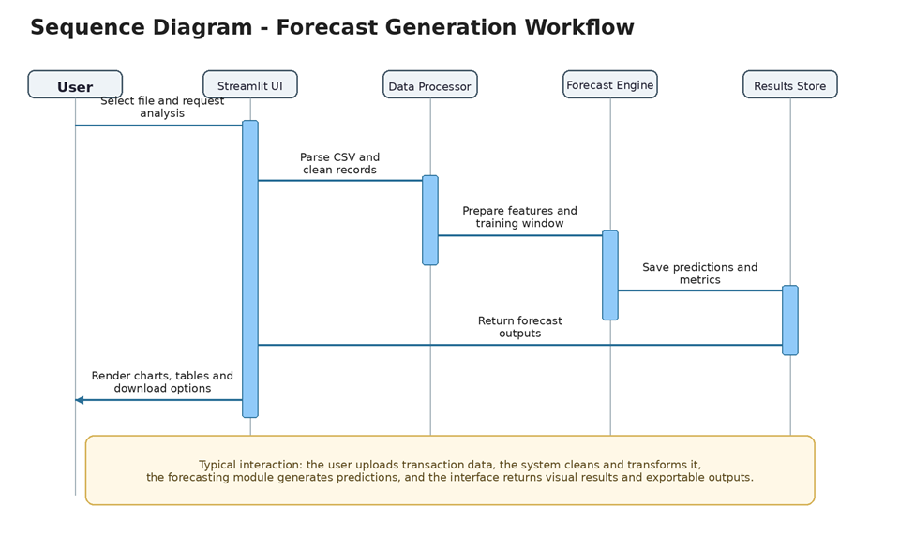
5.2 Test strategy
The testing was to be done in three levels namely unit testing, integration testing and system testing. The purposes of each level were different. Unit tests were concentrated on individual functions. These capabilities were preprocessing, feature generation and metric handling. It was aimed at determining whether every function worked well individually.
Integration tests were concerned with the interface between components of a system. These tests determined whether uploaded files would be able to pass through the cleaning pipeline and subsequently into the visualisation or forecasting layers. This was necessary as the system required various modules that should collaborate well.
The system testing was aimed at the entire user experience. These tests ensured that the whole process was checked all the way through. They also had local deployment by use of the batch script.

Test ID | Level | Focus | Pass criterion | Requirement link
UT-01 | Unit | clean_product_name() | The function removes unwanted prefixes, symbols, and inconsistent formatting, but it keeps valid product names correct. | FR2
UT-02 | Unit | safe_mape() | The function is safe in case the actual sales have zero values hence the system does not break down due to division by zero. | NFR4, NFR5
IT-01 | Integration | Upload to DataFrame pipeline | The system combines multiple uploaded files into one clean daily dataset and does not create duplicate date records. | FR1, FR2, FR3
IT-02 | Integration | Model evaluation page | The page compares model metrics correctly and shows the best option based on validation results. | FR4, NFR5
ST-01 | System | run_bristol_pink.bat | A Windows user can start the application and open the dashboard through the batch script without manual setup. | NFR2
UAT-01 | User acceptance | Forecast controls | When the user changes the training window or product selection, the forecast updates correctly and within a reasonable delay. | FR5, NFR3

As Table= 2 indicates, the primary tests applied in the project are as follows. The test plan included unit testing, integration testing, system testing and user acceptance testing. This design enabled the team to test individual functions, connections between modules, entire system utilization and control of forecast settings by the users. Both functional requirements and non-functional requirements were also supported by the test plan.

6. Implementation and Testing
6.1 Core implementation decisions
The system was constructed using Python 3. The primary tools included Streamlit, Pandas, NumPy, Plotly, and Scikit-learn. one of the good aspects of the implementation is its practicality. The project did not attempt to create a system that was overly large or complex. Rather, the team came up with a local application which can be run easily, supported easily and understood easily by students who have normal skills in Python.

The source code further indicates that the system has distinct helper functions to carry out key tasks. These are cleaning filenames, reading CSV structures, construction of full daily time series and training forecasting models. This design allows reuse of codes and simplifies testing and maintenance of the system.
Random Forest model employs a number of engineered time-based features. These are lag_1, lag_7, rolling_mean_7 and day_of_week. This decision is logical since the demand on products may rely on recent sales fluctuations and weekly trends. The system also transforms negative predictions into zero. It is a minor design decision, but it matters in practice since negative values of sales would not be appropriate in a real business environment.
The interface design is also practical. The dashboard has a sidebar and different pages. These pages are the Home, Historical Analysis, Forecast Studio, Model Evaluation, and Data Centre. This layout is better than putting everything on one long page. It gives each task its own space and helps the user deal with one question at a time
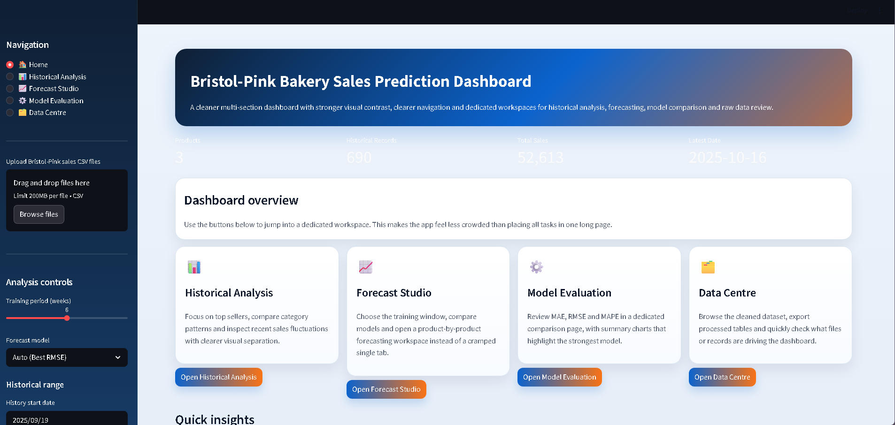

6.2 Historical analysis outputs
The historical analysis view will assist the users to realize the previous sales before they embrace any forecast outcome. This is significant as a forecast ought to be viewed in context of previous sales behaviour and not independently.
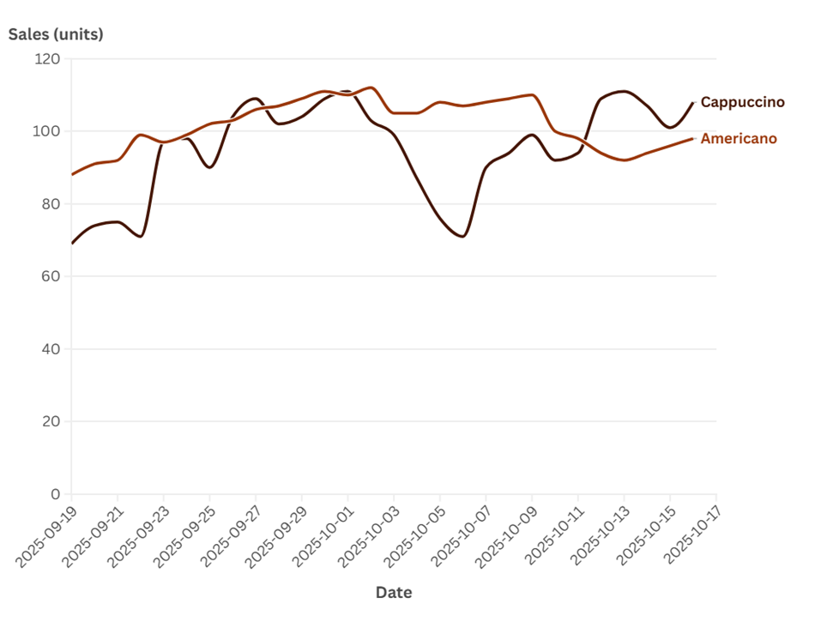
Figure 4 is a comparison of two major coffee products, Americano and Cappuccino. This chart can be useful since it indicates the general level of sales as well as the degree of change with time. The two items seem to share a comparable overall sales range. But their line patterns are not exactly the same. Such a difference implies that there is no single demand pattern followed by the products. Due to this reason, model comparison would be more suitable than believing that one model will suit all products equally.
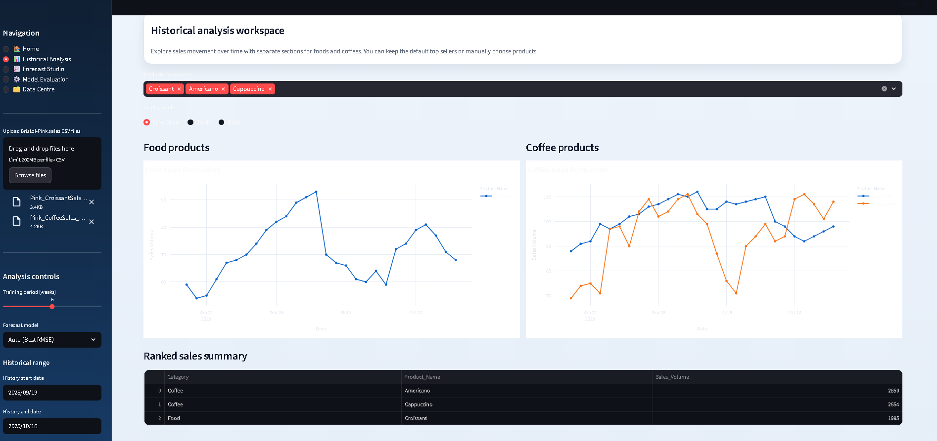

6.3 Forecast generation and model evaluation
The forecast studio allows the user to select the training window. The user also has an option of choosing a model manually or automatic model selection depending on the valiidation outcomes. This design provides a balance between control and simplicity by the users. Direct comparison of models can be done by a more experienced user. The dashboard can be allowed to choose the model through its evaluation results by a less technical user.
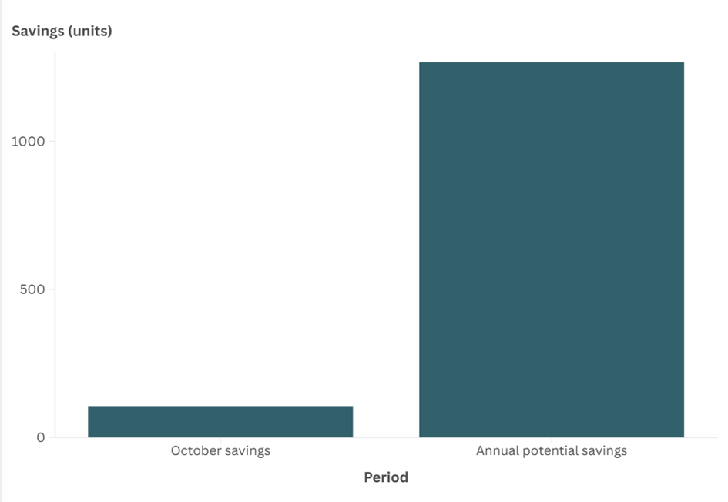

Figure 5. Estimated monthly and annual savings from reduced waste
Figure 5 indicates the projected savings that are associated with waste reduction. The graph compares October savings and annual potential savings. This output can be used to relate forecast results to possible business value. It demonstrates that improved forecasting could assist in reducing waste and making better stock decisions. Nevertheless, the precise financial implication of these values would still require additional confirmation within a real business environment.

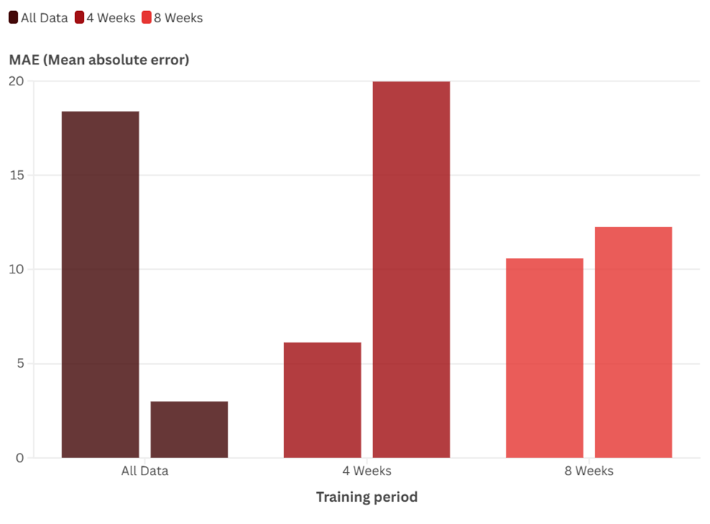
Figure 6. Predicted Americano sales for the next 28 days under different training windows
Figure 6 presents the sales forecast of Americano in 28 days with three training conditions, i.e. all data, 4 weeks and 8 weeks. The graph indicates that the predicted outcomes do not remain consistent when the training window is altered. The general trend is also comparable, but the estimated level of sales differs among the three environments. This implies that the quantity of recent information incorporated in training can influence the final prediction. To this end, the system enables the user to select the training window rather than concealing this option.

6.4 Output quality and business-facing insights
The accuracy of the forecast was not the only concern of the project. The dashboard also attempted to demonstrate why business-wise the result of the forecast is important. This renders the output more decision-making relevant.
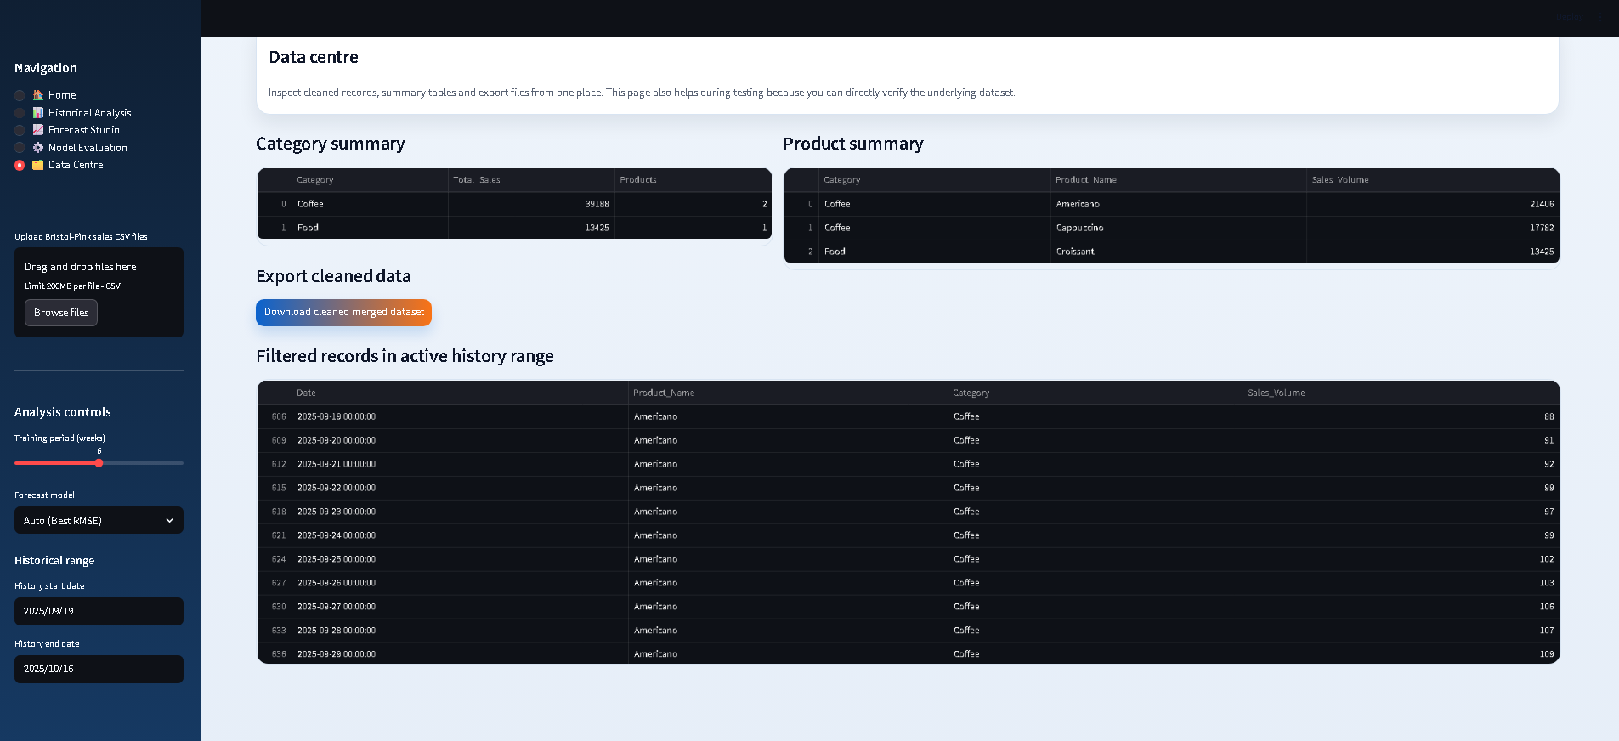

7. Evaluation and Reflection

7.1 Evaluation against objectives
The project has succeeded in its primary objective. The group came up with a working dashboard of local demand analysis and forecasting. It is multi-product based. It also compares models, displays performance metrics and gives a deployment method that can be used on a standard Windows computer.
The project was also sensitive to the objective of making the system usable by a non-technical manager. The dashboard has individual pages, chart-based interaction and export in CSV. All these characteristics simplify the navigation of the system as well as its use in practice.
Simultaneously, not all initial objectives were fulfilled to the same degree. The dashboard has an effective forecasting tool which however is yet to be a fully proven production system. This difference is important. An excellent student project does not necessarily have to be presented as an enterprise product. Rather it must demonstrate definite needs, good execution and sincere assessment.

7.2 Use of feedback
Feedback was significant in the development process. It proved particularly useful in enhancing the interface design. The initial versions of the dashboard were more cluttered. Due to this, users found it difficult to understand the relationship between descriptive analysis, model evaluation and forecasting.
The team restructured the dashboard into individual workspaces later. This modification enhanced navigation and provided a clearer system structure. It also simplified the report. The example is helpful since the feedback resulted in an apparent design modification, rather than merely a brief note in the reflection section.

7.3 Ethics, safety, and sustainability
The project considered the issues of ethics and safety primarily by processing data locally. The system was not based on a cloud-first design. Due to this, there was less risk of sensitive sales information being revealed to third-party services. This is also an appropriate design decision in the business environment. Simplicity and control can provide more value to a small business than remote infrastructure.
The project was focused on sustainability in terms of its practicality. Overproduction can be minimized by better short term forecasts. Reduced overproduction is then able to minimize food wastage. But this statement must not be exaggerated and excessive. The dashboard does not eliminate waste per se. It simply offers data that might assist in making more informed choices.
7.4 Critical reflection and future work
Overall integration is one of the advantages of this project. The system combines data processing, visual analysis and prediction in one application. This provides a clear and logical structure for the project.
The project also has clear boundaries. This kind of restriction is very common in students' work. The range of data available is not wide. The verification time is also very short. In addition, the system relies on the uploaded CSV file, not the fixed operating data source.
There will be some enhancements that may be real in the future. First of all, these models will be tested on a longer time frame and more products. This will reduce the performance results to a shorter data window. Secondly, background factors such as weather, promotions or holidays can be included in the system. These aspects may affect the demand of cafes. Third, the system may replace direct CSV upload with a small database. This will make the dashboard more stable and easier to expand. These improvements are practical because they are based on the existing design, rather than installation of a new system.

References
Bandara, K. , Bergmeir, C. and Smyl, S. (2020) Forecasting across time series databases using recurrent neural networks on groups of similar series: A clustering approach Expert Systems with Applications, 140, p. 112896.
Carbonneau, R., Laframboise, K. and Vahidov, R. (2008) Application of machine learning techniques to supply chain demand forecasting, European Journal of Operational Research, 184(3), pp. 1140-1154.
Chase, C.W. (2013) Demand-Driven Forecasting: A structured approach to forecasting. Hoboken, NJ: John Wiley & Sons.
Chen, H., Chiang, R.H.L. and Storey, V.C. (2012) Business intelligence and analytics: From big data to big impact, MIS Quarterly, 36(4), pp. 1165-1188.
Eckerson, W.W. (2010) Performance Dashboards: Measuring, monitoring, and managing your business. 2nd edn. Hoboken, NJ: John Wiley & Sons.

Few, S. (2013) Information Dashboard Design: Displaying data for at-a-glance monitoring. 2nd edn. Burlingame, CA: Analytics Press.
Fildes, R., Goodwin, P., Lawrence, M. and Nikolopoulos, K. (2009) Effective forecasting and judgmental adjustments: An empirical assessment and strategies to improve in supply-chain planning, International Journal of Forecasting, 25(1), pp. 3-23.
Hyndman, R.J. and Athanasopoulos, G. (2018) Forecasting: Principles and practice. 2nd edn. Melbourne: OTexts.
Knaflic, C.N. (2015) Storytelling with Data: A data visualization guide for business professionals. Hoboken, NJ: John Wiley & Sons.
Makridakis, S., Spiliotis, E. and Assimakopoulos, V. (2018) Statistical and machine learning forecasting methods: Concerns and ways forward, PLoS ONE, 13(3), p. e0194889.
Makridakis, S., Spiliotis, E. and Assimakopoulos, V. (2020) The M4 Competition: 100,000 time series and 61 forecasting methods, International Journal of Forecasting, 36(1), pp. 54-74.
Petropoulos, F., Makridakis, S., Assimakopoulos, V. and Nikolopoulos, K. (2014) Horses for courses in demand forecasting, European Journal of Operational Research, 237(1), pp. 152-163.
Seeger, M.W., Salinas, D. and Flunkert, V. (2016) Bayesian intermittent demand forecasting of large inventories in Lee, D.D., Sugiyama, M., Luxburg, U.V., Guyon, I. and Garnett, R. (eds.) Advances in Neural Information Processing Systems 29. Red Hook, NY: Curran Associates, pp. 4646-4654.
Yigitbasioglu, O.M. and Velcu, O. (2012) A review of dashboards in performance management: Implications to design and research International Journal of Accounting Information Systems, 13(1), pp. 41-59.
Zhang, G., Patuwo, B.E. and Hu, M.Y. (1998) Forecasting with artificial neural networks: The state of the art International Journal of Forecasting, 14(1), pp. 35-62.

Individual Report

UDDIN, NADER 24061972
In my group, I was the back-end developer responsible for the main Python operations of the system (e.g., data cleaning, feature engineering). Our group project was to develop a bakery forecasting sales dashboard running locally which transforms previous sales data into tools for assisting with daily inventory management. The system was eventually constructed using Python 3, Streamlit, Pandas, NumPy, Plotly, and Scikit-learn. This decision of technology demanded a backend to be robust enough, testable, and maintainable.

The main issue I found was that handling real CSV data was more difficult than the model itself. Uploaded files might have missing values, wrong column names, and inaccurate labels. If these problems aren't fixed right away, later modules could be affected. Another challenge for me was changing randomly formatted files into a consistent, predictable daily dataset.Then, my early efforts were mainly focused on the cleaning logic, which had product name cleaning, CSV structure reading, and full daily - time - series preparation. Risk R02 in the given document says that the system has to have defensive processing and cleaning routines, such as for a few zero - related values, incorrect file structures, and unclear labels. The test plan also validates this point. UT - 01 specifically checks whether 'clean_product_name()' can get rid of unneeded prefixes, symbols, and unclear formatting while keeping the correct product names. IT - 01 requires the use of the File Upload to DataFrame pipeline to combine lots of submitted files into an organized daily dataset and avoid duplicate date records. Putting all these things in order, the entire process of unifying names, aggregating a large number of files, and creating a daily timeline was arduous and took a lot of my time and energy.

At Python implementation level: First, I included some practical but significant design features. The code offers modular helper tools to carry out recurring operations that involve product name cleaning, timeline preparation, Random Forest design and metric calculation. This reduces the duplication of code and makes testing and maintenance easier. Engineering characteristics such as lag_1, lag_7, rolling_mean_7, and day_of_week are also used by Random Forest since sales demand is usually affected by past variations in sales and trends on weekdays. One other notable step was to make negative forecasts zero. This small point made me realize that outputs of models should not only be theoretically right, but they should also conform to real company logic, because real sales data cannot be negative.

Moreover, the project is concerned with the overall operability and testability of the system. It does not seek to develop complex technologies but rather develops a locally executable application in Python 3, Streamlit, Pandas, NumPy, Plotly, and Scikit-learn. The strategy fits better in the context of small businesses and enables the team to install and maintain on an ordinary Windows platform. Regarding the code structure, the system is based on a layered model where front-end interface, data processing and prediction logic are separated. This implies that changes in sites do not directly affect the model and that data cleaning and prediction logic can be tested independently. More than that, I paid most attention to the methods through which the Python implementation would enable real user operations. To illustrate, can a file easily get into the cleaning process and then transferred to the display and forecasting pages? Lastly, when the user switches between training window and product selection, is the forecast updated timely by the system? In my opinion, these parts will make the entire flow of data, page calls, and local deployment more reliable, allowing other members of the team to test and use the system appropriately.

I understood the need for cooperation and interaction in backend operations because of this project. Thence, Git and weekly discussions helped us move ahead with the project smoothly. They gave us the ability to find problems brought on by API changes earlier in the process, thus raising efficiency among the frontend, QA, and backend teams. As a backend engineer, I came to realize that many supposed technical problems are actually communication problems. To be exact, system development needs careful focus on code execution, suitable results, and the real - life user's interaction. We need a better understanding of whether the page can update easily as users move between product or training windows, and how backend operations balance the model implementation, system stability, and the user experience.

To improve, I think the biggest steps are to use longer term data, introduce new categories of products, include background factors such as weather or holidays and gradually replace direct csv inputs with databases.

YU, YUNZE 25028284
I took on the role of Business Analyst and Market Watcher in this project and my main duties were to analyse the business context, set SMART objectives and organise system requirements. Before the start of the project, I thought that the main duty of this role was to understand the background of the industry, read relevant papers and then create requirements. After I got actively involved in the project, I slowly began to realise that this role was much more complicated than I had imagined.
The primary difficulties that I have faced are in two areas. To begin with, the project does not involve real users on a continuous basis; secondly, there are only two CSV files as the available data resources. In such circumstances, it is hard to correctly determine the needs that target users actually care about and also hard to determine what system functions are most valuable when applied in real-life situations. This also indicates that demand is not connected to practical use and diminishes the effectiveness of design of systems in practice. Despite our definition of the target users as being bakery managers, most of the decisions are still based primarily on literature, case studies and group discussions instead of direct feedback of actual stores.
Through this experience, I came to understand that demand analysis has a high level of uncertainty. At the start, my view of the system requirements was rather idealistic. I aimed to show the project's wholeness by adding functions. As the project goes on, I come to realize that it's more important to regulate the scope in the core and verifiable part. Evade the risks caused by the testing and system integration phase. So, I later got the team to focus on core functions like CSV uploading, historical analysis, model comparison, and 28 - day prediction. This adjustment improves development efficiency and enhances the synergy between teams.
Another issue was the gap between the literature and the real needs. At first, I tended to follow more the things that I read e.g., about forecasting techniques, about designing a dashboard, about decision support for SMEs, which did not really map into system design. Later on, I started grasping how to map some theoretical principle into a concrete requirement. For instance, the principle of a friendly user interface was mapped into decisions about the page layout and the design of functional modules. This helped me produce a more rational system design and a solution which is better founded theoretically.
I also slowly understood that requirements analysis is not a task that can be achieved only in the early stage. Since there is limited data and the team is doing parallel front - end and back - end development, any uncertainty in requirement expression may slow the project down. If requirements are not clear, the front - end may struggle to decide on the priorities of interfaces, the back - end may have issues in arranging the outputs, and the testing stage will be more difficult as there are no clear standards. It further shows the significance of exact requirement definition in project risk management.

As a result, continuous communication with front - end, back - end, and testing members in the course of development is needed. This experience made me more conscious of the importance of group work. Many problems can't be solved by an individual and need continuous alignment and adjustment to reduce misunderstandings.
Overall, this project has provided me with a more hands-on knowledge of the role of Business Analyst. I understand that the analysis of demand should be integrated with the background of users, data restrictions and constraints of the project, and not only on idealized assumptions. Simultaneously, there must be a distinct logical relationship between literature, requirements, design and implementation. In case I engage in such projects again, I will conduct user demand and business model research at an earlier stage, experiment with more direct user verification techniques, and rely less on assumptions. Meanwhile, I will also facilitate the alignment of departments sooner, in order to have the team moving towards a more definite direction right at the start. Altogether, this experience did not only make me a better analyst but it also allowed me to lead the team to develop plans in the face of uncertainty.

YANG, HAODONG 25061288
In the group, I was put in charge of quality assurance (QA) and project evaluation. Our system had in it CSV upload, data cleaning, historical analysis, model comparison, and forecast controls. At the very start, each individual module seemed to work well when considered in isolation. However, once these modules were linked up, problems slowly showed themselves. In particular, when developing the front end and back end at once, any change in data structures, function inputs, or page logic could have an effect on the whole workflow if not communicated in due time. QA thus needed not just bug checking but also ongoing communication, testing, and validation. As a consequence, I found that this role was far more difficult than I'd first believed.

One of the most difficult aspects of the project was that the time available for testing was always tighter than foreseen. In the planning process, it's common for a team to think they can develop the main functions first and then conduct testing in a concentrated period. In reality, though, the situation was rather different. Development was in a constant state of modification. The front - end pages were re - worked, the back - end logic was adjusted, and in many cases, the system was updated before the earlier round of testing was over. In view of this, it was difficult to wait for a fully stable version before beginning the testing work. I therefore came to the realization that testing has to be introduced earlier, especially for high - risk elements like the cleaning pipeline, the model evaluation page, and the proper update of forecasts when users change product selection or training window. This made me see the value of finding the system's weak spots in advance.

Moreover, I also did not expect how hard it would be to establish the right testing standards. The unit tests of functions like clean_product_name() and safe_mape() were comparatively straightforward since the success or failure criteria were usually obvious. Nevertheless, at system testing and user acceptance testing levels, the standards were far less absolute. As an illustration, the documentation necessitated that the system should update results within a reasonable time lag after the user altered the training window or product selection. Such a requirement may appear to be completely natural but during testing it becomes evident that there is no one exact answer to it as in a mathematical problem. All judgements regarding interface clarity, page transitions and overall user experience must be based on actual usage scenarios.

I found feedback to be of great value in this role. In the beginning of the project, the dashboard was in a state of disorganization. As too many elements were put together, users couldn't immediately figure out the relationship between descriptive analysis, model evaluation, and forecasting. Later, on account of the feedback, the team re - ordered the dashboard into several clearer work zones. This modification made the interface look better and supported the testing process. Since the workflow got clearer, it was easier for me to figure out what to verify on each page and at which steps mistakes were likely to occur. From my point of view, this showed that evaluation is not a separate function. It has to be constantly documented and used to inform ongoing project alterations.

The most valuable lesson that I have learned after this project is that I do not consider QA to be an end-stage activity. Rather, it serves as a tool of assisting the team in constantly ensuring that the system is actually ready to be used by other people and also aiding continuous debugging and optimisation. In future, I would attempt to clarify ambiguous requirements at an early stage like expectations on page response time, user operation paths and format of error messages. This would allow the team to enhance communication efficiency and collaborative effectiveness better.

XIE, JIAQI 25028285
For our group, I was chiefly in charge of front - end UI design. The main task I had was to use Streamlit to build the system interface so that users could upload data, view charts, compare models, and generate forecasts. At the start of the project, I thought the main aim of front - end development was just to make pages enabling users to access and use functions smoothly. When the development started, I rapidly found that front - end work consists of much more than page layout and button design. I found the most difficult part to be the strong interdependence between the front end, back end, data structure, and the whole user workflow. If there was an alteration in the back - end logic or data format, the front - end chart display, filtering methods, and parts of the interaction logic had to be changed. Consequently, many problems that seemed like UI bugs were actually due to unsynchronized information and poor communication during the integration phase. This experience made me more clearly appreciate that front - end development is not a self - sufficient task. It requires continuous interaction with back - end development and other team members. We could shrink rework and improve the group's overall efficiency only through stable communication.

The most important change in this project to me was the redesign of the page structure. Initially, I put the major functions on one page just out of convenience and hoping that the users would be able to see all the content together once they opened the system. In terms of implementation, this method was rather simple and saved some time in designing. Nevertheless, following the feedback provided by the lecturer and talking to the team about the problem, I slowly understood that despite the fact that a single-page layout seemed to be comprehensive, it created an impression of cluttered interface and the hierarchy of information was not clear enough. To a non-technical user, it was hard to tell at a glance between descriptive analysis, model evaluation, and forecasting, and equally challenging to trace the logic of the system step by step. We thus opted to use the original single page design instead of multiple switchable modules, which would show various tasks individually. Following this modification, the entire interface became significantly more logical: the user could initially look through the historical data, then compare models, and ultimately analyze the results of forecasting. This order was also more practical in terms of usage patterns. In my case, this revision helped me realize that front-end design does not only influence visual appearance but whether or not users can make sense of the system.
In addition, as I worked on finishing this project, I increasingly became conscious that our system was still quite simple in the UI. It could present data and do basic interaction, meeting the functional requirements of the course project. Still, there was an evident difference between our system and a mature product in visual hierarchy, interaction detail, and overall professionalism. As an example, the page had a simple look. Information presentation was mostly function - driven, and time constraints prevented further improvement of many details. It was partly due to the short - lived nature of the project, and partly because the team spent more effort on functional implementation, data processing, and system integration. As a consequence, the main purpose of the front - end component was to be clear, stable, and usable rather than going for more complex visual effects. This experience enabled me to understand more comprehensively that course project design often needs a careful equilibrium between visual appeal and deliverability.
This project made my understanding of front - end development more all - around. In earlier times, I mainly focused on the possibility of implementing pages and functions. Now, I realize that front - end work must also ensure a clear workflow, compatibility with back - end logic, and ease of use in real - world situations. This project has shown me that good front - end design should not only make a system usable but also make the user's experience smooth, clear, and dependable. In future project - related efforts, I'd think about page design and user journeys earlier and test interaction logic as I develop the project, rather than waiting until the effort is done. All in all, this experience allowed me to understand more precisely the role of the front end in software projects and the close connection between UI design and teamwork.
CHENG, JILONG 25028281

I have the job of sorting out the overall system structure, preparing UML records, and making certain the front - end, back - end, and pages are in line. I took part in the decomposition of system modules and user processes as well.
Fundamentally, the first thing I have to do is work out what users really want. The first - made version put everything on a dashboard page. After chatting with Xie Jiaqi and getting meeting feedback, it was found that this didn't work for users because there was an overload of information in one place. So we divide it into four pages: historical analysis, model evaluation, prediction, and raw data survey. For example, in the historical analysis module, you can do a comparison of the daily sales of cappuccino and American coffee. Store managers can view past sales trends here, which is useful for inventory management.
The first issue that I had was that the design document and the implementation were easily detached. We used to have a very clear system structure in the early days as we needed it, but when the document is not updated at the right time, you will eventually end up with the chart indicating a system, but the construction is entirely different.
The second issue is that the general setup is simpler. From the viewpoint of the course project, it makes sense - the system is largely local CSV upload, Streamlit interface and Python function for historical analysis, model comparison and 28 day prediction. Very simple. Summarise and demo in tight time. However, stepping back and considering from an architectural point of view, it is very basic - there is no more resilient data source, little automation and it is not provisioned as a highly scalable industrial strength system. Nonetheless, for a student project for small bakery or cafe scenarios, a clear, maintainable, demo-able structure is preferable to a flashy structure that evaporates during the integration process.
When it comes to team - work situations, I really get how my work is linked to collaboration and risk management. Construction is not an abstract work idea; it's a way to help the team fight against risks. So, in the project, I not only organized the operation and created graphical representations. I also helped everyone understand module inter - relationships, promoted communication, kept our logic on the right track, and ensured we all worked as per the same plan. This enabled me to understand the actual nature of team management. A good structure is not just a random task distribution; it's a communication tool that makes the team move in harmony even when things change.
In the morality and sustainability point of view, this position also causes me to consider more on how to establish boundaries and have control in mind. Our project processes sales data locally rather than leaping into the cloud priority - which minimizes the chances of transferring data to third parties and is more appropriate to small businesses that desire a simple and easy to manage. Besides, better short-term forecasts can actually minimize waste, but it does not cover all business-related waste solutions - we still have to continuously adapt depending on the real needs of users.
In case I carry out a comparable project in future, I will substitute the CSV data source with database or streaming data interface to make it more scalable. Overall, I managed to finish the simple chart, served as a lubricant of the communication between the team members and got a better idea of my job position.

